## **Lab 6 – Publish the Report**

## Power BI Desktop – Create Workspace and Publish the Report

You will now leverage a report authored using Power BI Desktop to create a dashboard for the VanArsdel data analysis team and CMO. A Power BI Desktop file with additional reports and visuals is provided.

Sign-in to Power BI using your user account. Once logged in, you will be taken to the **Home** screen.

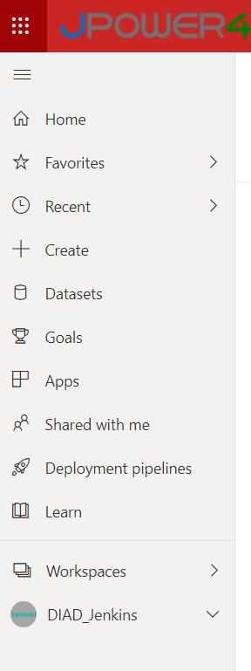

If the left navigation is collapsed, click the  (menu) icon below Power BI on the top left side of the screen to expand the left navigation.

The following options are listed in the left navigation:

* + **Home**: This is a one-stop-shop for all your content. It lists your favorite and recent content such as reports, dashboards, and apps. It also shows the most recent content that was shared with you.
  + **Favorites**: Lists all your favorite content. We will create a favorite in a later section.
  + **Recent**: Lists the most recent content you have viewed.
  + **Apps**: List all the apps you have installed.
  + **Shared with me**: Lists the content that is shared with you. We will share dashboards in a later section.
  + **Workspaces**: Lists all the workspaces you are assigned. By default, you are assigned to **My Workspace**.

Click the down arrow next to **My Workspace**. Notice the Dashboards, Reports, Workbooks, and Datasets sections. Let’s import a Power BI Desktop file and create dashboards.

My Workspace is your personal workspace. We need to create a workspace where we can collaborate with team members and distribute content to end-users. To do this we’ll create a new workspace.

1. In the left panel, click **Workspaces** and then click **Create a workspace**. The **Create a workspace**

dialog box opens.

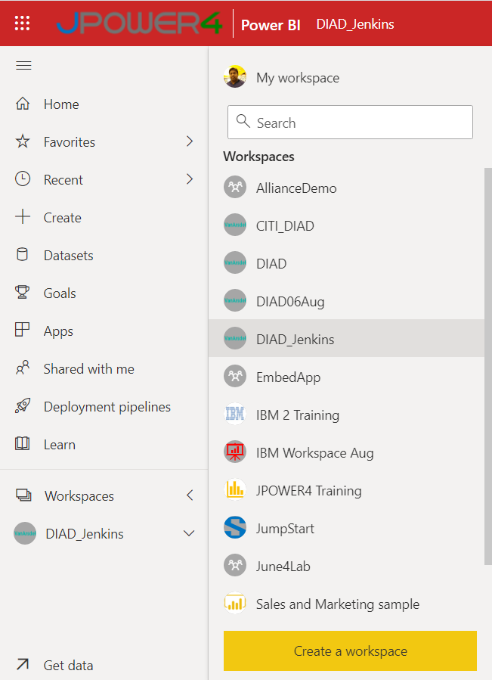

1. In the **Create a workspace** dialog box, click **Upload**.
2. A file browser dialog box opens. Browse to the **Data** folder (**/Data**). Click **VanArsdel_WSLogo** file.
3. In the **Name your workspace** text area, type **DIAD_<youremailaddress>**.
4. In the **Description** text area, type **This is DIAD workspace**.
5. Click **Save** to create the workspace.

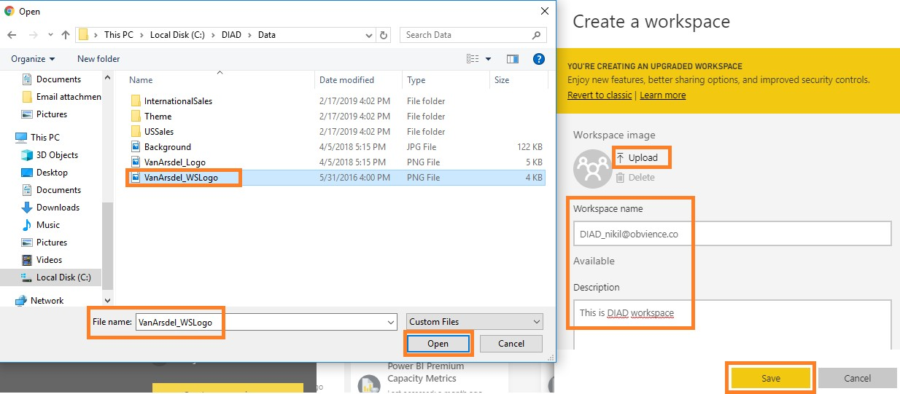

**Note**: You are entering your email address as part of the workspace name to keep it unique.

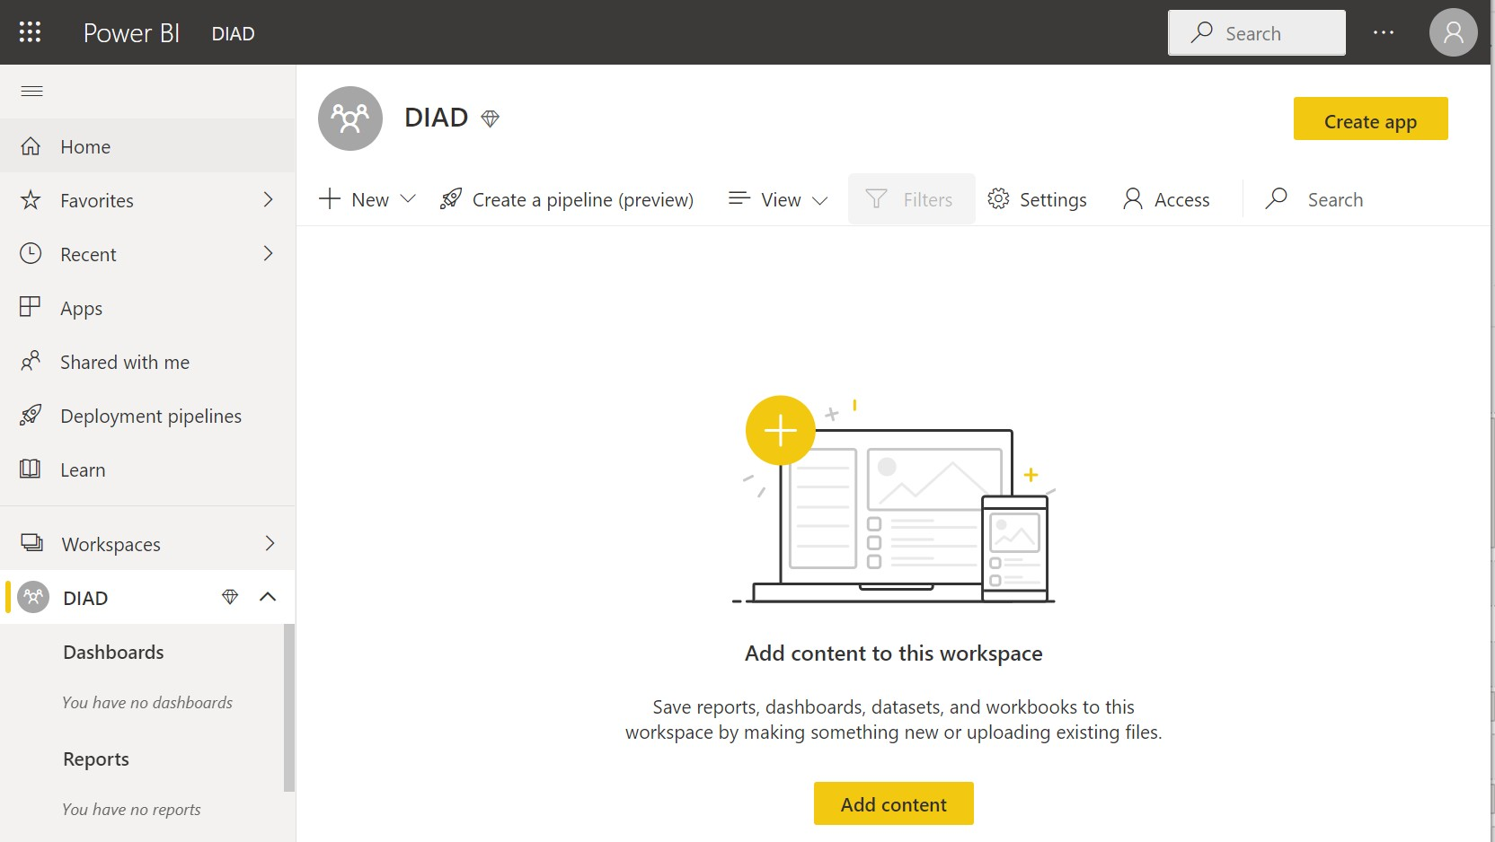

Notice that you have navigated from My Workspace to the workspace just created. You are in the

**Welcome** screen with options to discover or create content.

**Add content** has options to connect to Files, Databases, and Dataflows. There are two options to publish the Power BI Desktop report we created:

* + **Get** option under Files.
  + **Publish** from Power BI Desktop.

We are going to use the **Publish** from Power BI Desktop option.

Let’s publish the report to Power BI Service and then we will come back to the browser.

1. Navigate back to the **Final Report.**
2. From the **Home** tab, click **Publish.**

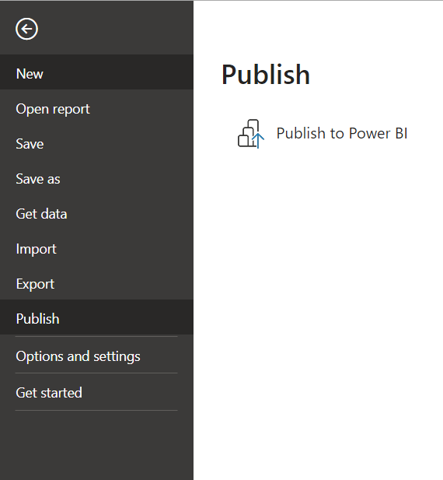

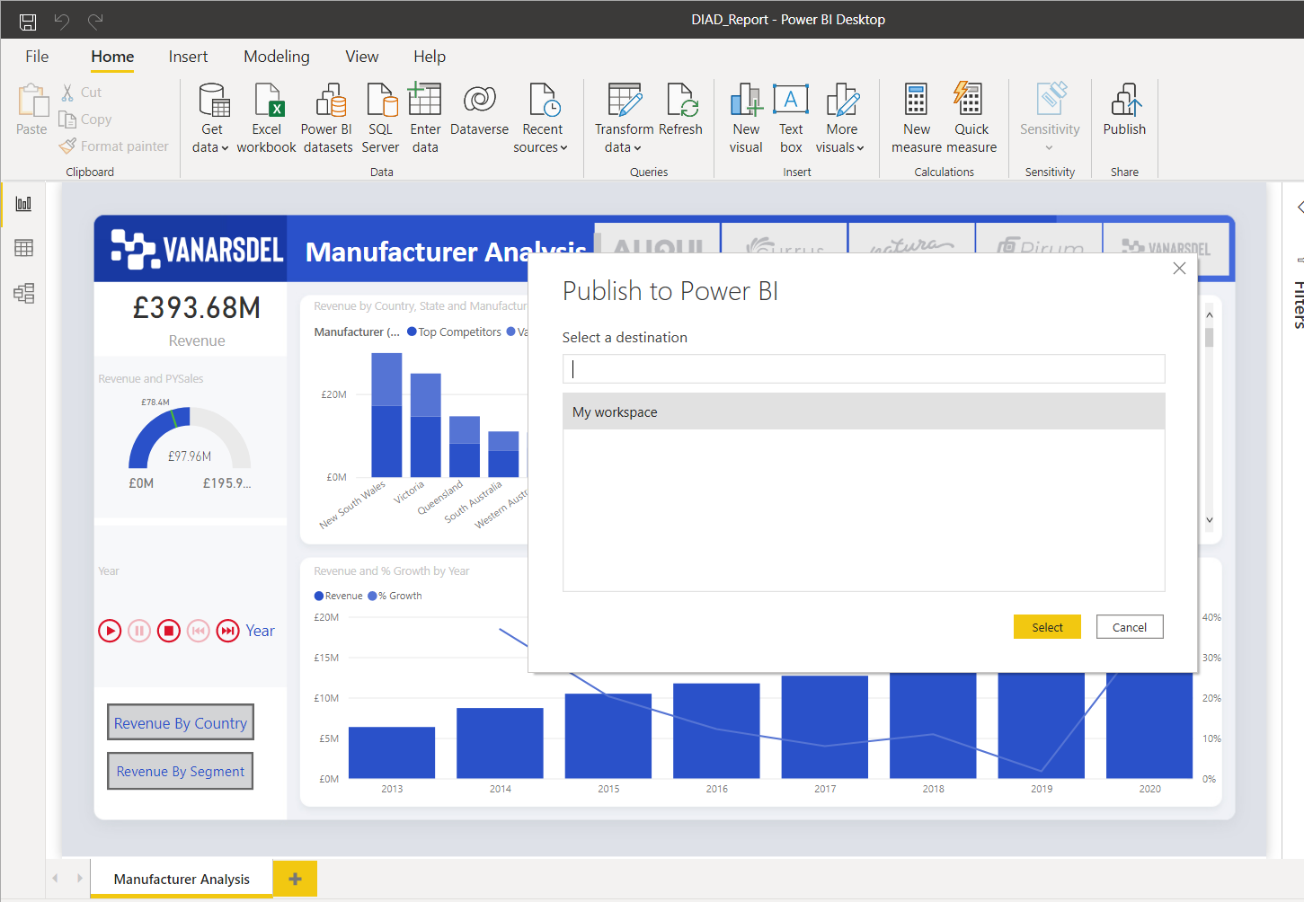

1. If you have not already logged into Power BI, a **Sign in** dialog box opens. Please sign in.
2. Once you are signed in, the **Publish to Power BI** dialog box opens. Click **DIAD_<youremailaddress>**

in the dialog box.

1. Click **Select**.

The **Publishing to Power BI** dialog box opens. Once the process is complete, a success message displays.

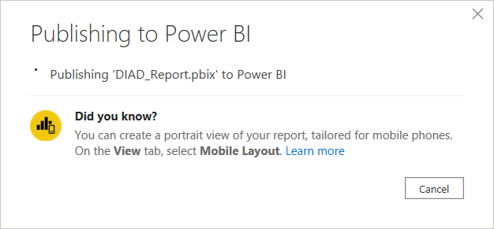

1. Click **Got it** to close the dialog box.
2. Open PowerBI Service and see the report

